Name: T.Jashwanth
Reg No:192572109

Experiment-3
Date:
Create a simple cloud software application for Property Buying & Rental process (In Chennai city) using any Cloud Service Provider to demonstrate SaaS
Aim:
To develop a simple cloud-based Property Buying & Rental application for Chennai City using Zoho Creator, demonstrating the Software as a Service (SaaS) cloud model for managing customer property rental information and calculating the total rental amount.

Procedure
- Log in to Zoho Creator.
- Create a new application named Property Buying & Rental System.
- Create a form and add the following fields:
  - Customer Name
  - Property Type
  - Monthly Rent
  - Months
  - Total Amount
- Configure Total Amount as the output field.
- Add a Deluge script to calculate:
Total Amount = Monthly Rent × Months
- Save the application.
- Run the application in the cloud.
- Enter customer and property details.
- The application calculates and displays the total rental amount automatically.
- Verify the output and save the record.

Implementation:

if(input.Montly_Rent != null && input.Months != null)
{
input.Total_Amount = input.Montly_Rent * input.Months;
}
info "--------------------------------";
info "PROPERTY BUYING & RENTAL SYSTEM";
info "--------------------------------";
info "Customer Name : " + input.Customer_Name1;
info "Property Type : " + input.Property_type;
info "Montly Rent : Rs. " + input.Montly_Rent;
info "Months : " + input.Months;
info "Total Amount : Rs. " + input.Total_Amount;
info "Booking Status : Success";
info "Location : Chennai";

Output:
Screenshots:

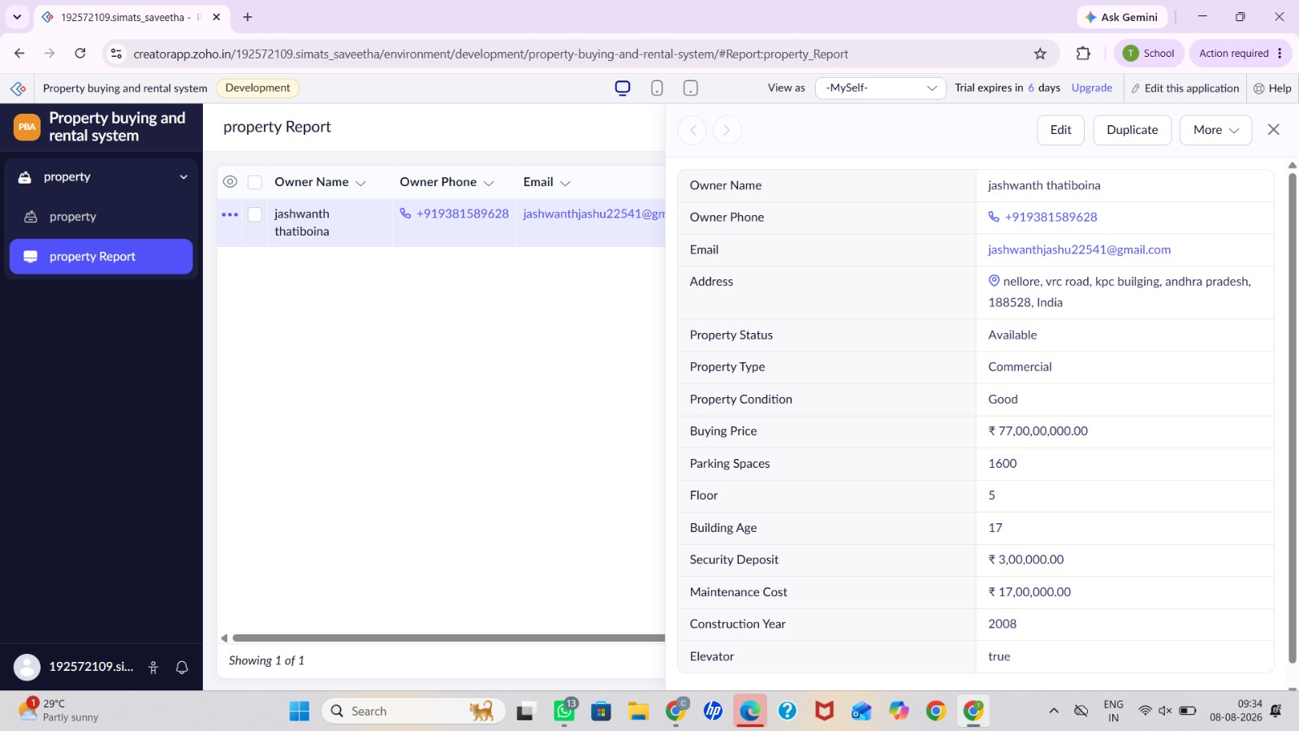

Result
The cloud-based Property Buying & Rental System was successfully created using Zoho Creator (SaaS). The application accepts customer and property details and automatically calculates the total rental amount, demonstrating the use of the Software as a Service (SaaS) cloud computing model.

